Version 1.01

BIOMETRIC Exit MObile application users guide

Installation:

There is no installation needed. To open the Identify application:

1. Make sure you have a browser and internet connection.

Supported browsers

1. Enter the following link in your browser’s search bar:

[https://s3.amazonaws.com/bio-sample-app-987452341283/index.html](%20https:/s3.amazonaws.com/bio-sample-app-987452341283/index.html)

C:\Users\EHGDI9E\Desktop\Phone App User Guide\urlBar.PNG

https://s3.amazonaws.com/bio-sample-app-987452341283/index.html

1. Go to the link.
2. A Login Screen will appear.

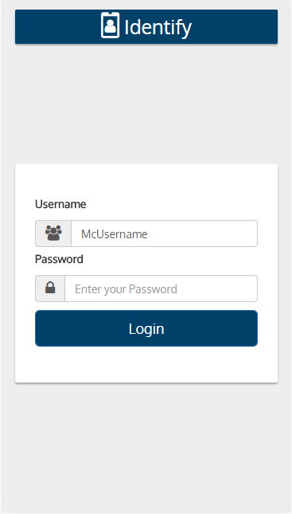

Logging In:



2

1

Login Page

1. Enter user name and password
2. Press Login and you will be presented with the Main Page of the application.

Using the Application:

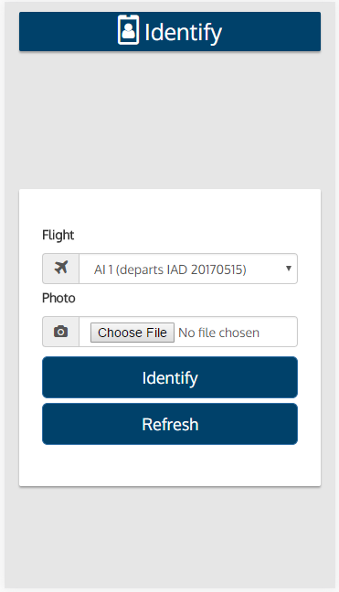

Main Page

3

2

1

1. Select a flight.
2. Take a photo.
3. Press the Identify button.
4. Get a result.

Results Page

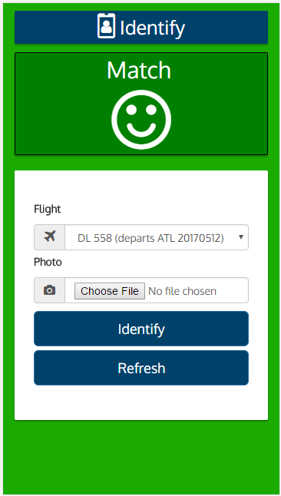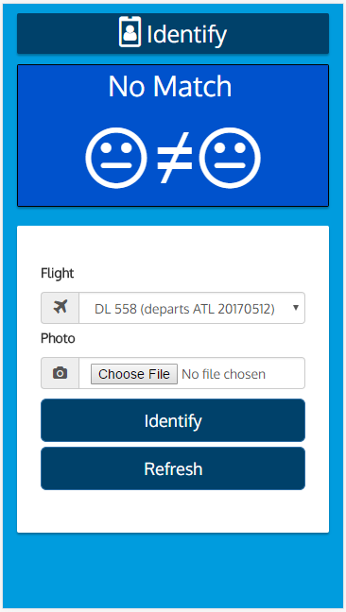

4

\*You may choose to take another picture by following Steps 1-4.

Refreshing or Resetting:

If you want to reset or refresh the main page:



Press Refresh to refresh and reset on the main page.

Troubleshooting:

Possible Errors

Invalid Input

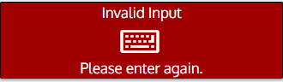

All Fields Required

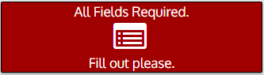

Dataset not yet assigned

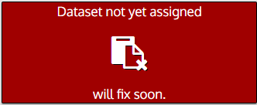

Failed to decode image

